**Supplementary materials**

Code:

Code used for data processing and analysis is available in the following open-source repository: <https://github.com/TWFrench/GI_complications_after_cardiac_sugery>.

**Supplementary Table 1: ICD-10 codes for complications and cohort descriptives.**

|  |  |
| --- | --- |
|  |  |
| Diagnosis | Corresponding ICD-10 codes |
| Heart failure | I50.0 – I50.9 |
| Pneumonia | J18 |
| Permanent pace-maker implantation | Z45.0 |
| Atrial fibrillation | I48.0 – I48.91 |
| Renal failure | N17.9, N18.5-N18.9, N19, R34 |
| Diabetic status | E101-E109, E1100-E119 |
| Aortic dissection | I71.0 |
| Ischaemic limb | I99.8, I70.90, I70.24, I70.21, I70.26 |
| Myocardial infarction | I21.0-I22.9 |
| Transient ischaemic attack | G45.9 |
| Cerebrovascular accident | I60-I66.9 |
| ICD-10: Tenth edition of the international classification of diseases. | |

|  |  |
| --- | --- |
| Supplementary Table 2: Definition of a post-operative vascular complication. | |
| Any one of the following: |  |
|  | New post-operative ischaemic limb |
|  | New post-operative myocardial infarction |
|  | New post-operative TIA with or without complete resolution |
|  | New post-operative cerebrovascular accident, with or without resolution |
|  | New post-operative iatrogenic aortic dissection |
| TIA: Transient ischaemic attack. | |

**Supplementary Table 3: ICD-10 codes and for relevant GI complications.**

|  |  |
| --- | --- |
|  |  |
| Diagnosis | Corresponding ICD-10 codes |
| Mesenteric ischaemia | K55.0, K 55.9 |
| Small bowel obstruction | K91.3, K55.1, K31.5, K56.6 |
| GI bleed | K29.0, K29.01, I85.01, I85.11, K57.0, K25-K28, K92.2 |
| Viscus perforation | K57.0, K57.2, K57.4, K57.8, K63.1, K22.3 |
| Ischaemic colitis | K55.0, K55.9 |
| Ileus | K56.0, K 56.6 |
| Transaminitis | R74.0 |
| Infective gastroenteritis | A00-A09.9, B57.3, |
| Cholecystitis | K80.0, K80.1, K80.4, K 81.0-81.9, |
| Pancreatitis | K85.0-K85.9 |

|  |  |  |  |  |
| --- | --- | --- | --- | --- |
| Supplementary Table 4: Sensitivity analysis – unadjusted odds ratios for potential predictors, excluding patients for whom data was missing. | | | | |
| Characteristic |  | Odds ratio | Confidence interval | *p* value |
| Age (years) |  | 1.04 | 1.02 - 1.06 | 0.001 |
| Female sex |  | 1.16 | 0.786 - 1.71 | 0.453 |
| Smoking status | Never smoked | 1.00 | (ref) |  |
|  | Ex-smoker | 1.18 | 0.804 - 1.74 | 0.393 |
|  | Current smoker | 1.53 | 0.944 - 2.48 | 0.084 |
| Hypertension |  | 1.38 | 0.91 - 2.08 | 0.130 |
| Diabetic status | Not diabetic | 1.00 | (ref) |  |
|  | Diabetes - diet controlled | 0.57 | 0.32 - 1.02 | 0.059 |
|  | Diabetes - On insulin | 0.77 | 0.312 - 1.89 | 0.568 |
| Preoperative renal failure |  | 1.83 | 0.665 - 5.04 | 0.241 |
| Known pulmonary disease |  | 1.00 | 0.571 - 1.76 | 0.992 |
| Known neurological disease |  | 2.07 | 1.27 - 3.38 | 0.003 |
| Angina status | CCS 0 | 1.00 | (ref) |  |
|  | CCS 1 | 1.24 | 0.676 - 2.29 | 0.484 |
|  | CCS 2 | 0.56 | 0.298 - 1.05 | 0.070 |
|  | CCS 3 | 0.67 | 0.375 - 1.21 | 0.186 |
|  | CCS 4 | 1.08 | 0.598 - 1.94 | 0.808 |
| Left main stem disease |  | 1.22 | 0.798 - 1.86 | 0.359 |
| Known CAD |  | 0.93 | 0.64 - 1.36 | 0.711 |
| Previous MI |  | 1.07 | 0.716 - 1.61 | 0.730 |
| Previous PCI |  | 1.21 | 0.71 - 2.06 | 0.485 |
| LVEF | Normal | 1.00 | (ref) |  |
|  | Moderate | 1.51 | 0.903 - 2.52 | 0.116 |
|  | Poor | 1.68 | 0.77 - 3.68 | 0.191 |
|  | Very poor | 8.27 | 2.42 - 28.2 | 0.001 |
| Reoperation (yes) |  | 1.79 | 0.65 - 4.92 | 0.260 |
| NYHA status | Grade I | 1.00 | (ref) |  |
|  | Grade II | 0.92 | 0.583 - 1.44 | 0.706 |
|  | Grade III | 1.10 | 0.725 - 1.67 | 0.653 |
|  | Grade IV | 1.28 | 0.735 - 2.23 | 0.383 |
| Abnormal preoperative rhythm |  | 1.85 | 1.16 - 2.95 | 0.010 |
| Operation urgency | Elective | 1.00 | (ref) |  |
|  | Urgent | 0.88 | 0.579 - 1.32 | 0.528 |
|  | Emergency | 3.11 | 1.49 - 6.49 | 0.003 |
|  | Salvage | 5.16 | 0.661 - 40.3 | 0.118 |
| Procedure weighting | Isolated CABG | 1.00 | (ref) |  |
|  | Isolated non-CABG | 0.66 | 0.437 - 1 | 0.051 |
|  | Two procedures | 2.42 | 1.66 - 3.51 | <0.001 |
|  | Three procedures | 2.42 | 1.17 - 5.04 | 0.018 |
| Preoperative inotropes |  | 1.67 | 0.404 - 6.89 | 0.479 |
| Cross-clamp time (minutes) |  | 1.00 | 1 - 1.01 | 0.001 |
| Bypass time (minutes) |  | 1.01 | 1 - 1.01 | <0.001 |
| One or more units of blood transfused |  | 1.20 | 0.293 - 4.94 | 0.798 |
| Postoperative vascular complication |  | 3.61 | 1.91 - 6.84 | <0.001 |
| Postoperative heart failure |  | 4.06 | 1.45 - 11.4 | 0.008 |
| Postoperative AF |  | 2.19 | 1.51 - 3.16 | <0.001 |
| CCS: Canadian society of cardiologists angina classification; CAD: Coronary artery disease; MI: Myocardial infarction; PCI: Percutaneous coronary intervention; LVEF: Left ventricular ejection fraction; NYHA: New York Heart Association Dyspnoea score; CABG: Coronary artery bypass grafting; AF: Atrial fibrillation | | | | |

|  |  |  |  |  |
| --- | --- | --- | --- | --- |
| Supplementary Table 5: Sensitivity analysis – Adjusted odds ratios for potential predictors, excluding patients for whom data was missing. | | | | |
| Characteristic |  | Odds ratio | Confidence interval | p value |
| Age over 80 |  | 2.76 | 1.54-4.96 | <0.001 |
| Sex (female) |  | 1.12 | 0.68 - 1.84 | 0.643 |
| Smoking status | Non-smoker | 1.00 | (ref) |  |
|  | Current smoker | 1.9 | 1.05-3.43 | 0.033 |
| Hypertension |  | 1.11 | 0.67 - 1.82 | 0.691 |
| Diabetic status | Not diabetic | 1.00 | (ref) |  |
|  | Diabetic - not on insulin | 0.60 | 0.29 - 1.27 | 0.184 |
|  | Diabetes on insulin | 0.55 | 0.13 - 2.28 | 0.412 |
| Known renal failure |  | 0.57 | 0.08 - 4.26 | 0.585 |
| Known pulmonary disease |  | 1.01 | 0.51 - 2 | 0.982 |
| Known neurological disease |  | 1.77 | 0.95 - 3.3 | 0.071 |
| Angina status | CCS 0 | 1.00 | (ref) |  |
|  | CCS 1 | 0.95 | 0.43 - 2.1 | 0.901 |
|  | CCS 2 | 0.5 | 0.21 - 1.16 | 0.105 |
|  | CCS 3 | 0.65 | 0.3 - 1.38 | 0.261 |
|  | CCS 4 | 0.61 | 0.24 - 1.55 | 0.298 |
| LMS disease |  | 1.68 | 0.96 - 2.92 | 0.069 |
| Known CAD |  | 0.89 | 0.56 - 1.43 | 0.637 |
| Previous MI |  | 1.25 | 0.73 - 2.13 | 0.414 |
| Previous PCI |  | 2.07 | 1.14 - 3.75 | 0.017 |
| LVEF | Good | 1.00 | (ref) |  |
|  | Moderate | 1.08 | 0.52 - 2.24 | 0.835 |
|  | Poor | 1.28 | 0.45 - 3.67 | 0.649 |
|  | Very poor | 4.59 | 0.53 - 39.47 | 0.165 |
| Reoperation (yes) |  | 1.90 | 0.57 - 6.3 | 0.295 |
| NYHA status | Grade I -II | 1.00 | (ref) |  |
|  | Grades III-IV | 1.08 | 0.67-1.71 | 0.759 |
| Abnormal pre-operative rhythm |  | 1.30 | 0.66 - 2.55 | 0.442 |
| Operation urgency | Elective | 1.00 | (ref) |  |
|  | Urgent | 0.75 | 0.41 - 1.35 | 0.332 |
|  | Emergency | 1.86 | 0.5 - 6.97 | 0.354 |
|  | Salvage | 2.68 | 0.23 - 31.81 | 0.435 |
| Number of procedures | Isolated CABG | 1.00 | (ref) |  |
|  | Isolated non-CABG | 0.79 | 0.48 - 1.31 | 0.360 |
|  | Two procedures | 1.68 | 1.03 - 2.75 | 0.036 |
|  | Three procedures | 1.84 | 0.72 - 4.69 | 0.201 |
| Preoperative inotropes |  | 4.98 | 1.12-22.1 | 0.033 |
| Cross clamp time (minutes) |  | 1.00 | 1 - 1.01 | 0.135 |
| Bypass time > 150 minutes |  | 1.89 | 1.09-3.26 | 0.023 |
| Post-operative vascular complication |  | 3.16 | 1.31-7.63 | 0.011 |
| Post-operative heart failure |  | 0.99 | 0.13-7.66 | 0.992 |
| Post-operative AF |  | 2.33 | 1.46-3.71 | <0.001 |
| CCS: Canadian society of cardiologists angina classification; CAD: Coronary artery disease; MI: Myocardial infarction; PCI: Percutaneous coronary intervention; LVEF: Left ventricular ejection fraction; NYHA: New York Heart Association Dyspnoea score; CABG: Coronary artery bypass grafting; AF: Atrial fibrillation | | | | | | |

|  |  |  |  |  |  |  |
| --- | --- | --- | --- | --- | --- | --- |
| Supplementary Table 6: Hazard ratios. | | | | | | |
|  | **Unadjusted** | | | **Adjusted* model** | | |
| Predictor | Hazard ratio | Confidence interval | p value | Hazard ratio | Confidence interval | p value |
| Serious GI complication (yes) | 2.53 | 1.87-3.42 | <0.001 | 1.22 | 0.87-1.71 | 0.254 |
| Additive euroscore | 1.07 | 1.07-1.08 | <0.001 | 1.07 | 1.06-1.07 | <0.001 |
| Length of stay (days) | 1.03 | 1.02-1.03 | <0.001 | 1.02 | 1.02-1.03 | <0.001 |
| *Adjusting for additive euroscore and length of stay. C statistic 0.729. GI: Gastrointestinal | | | | | | |

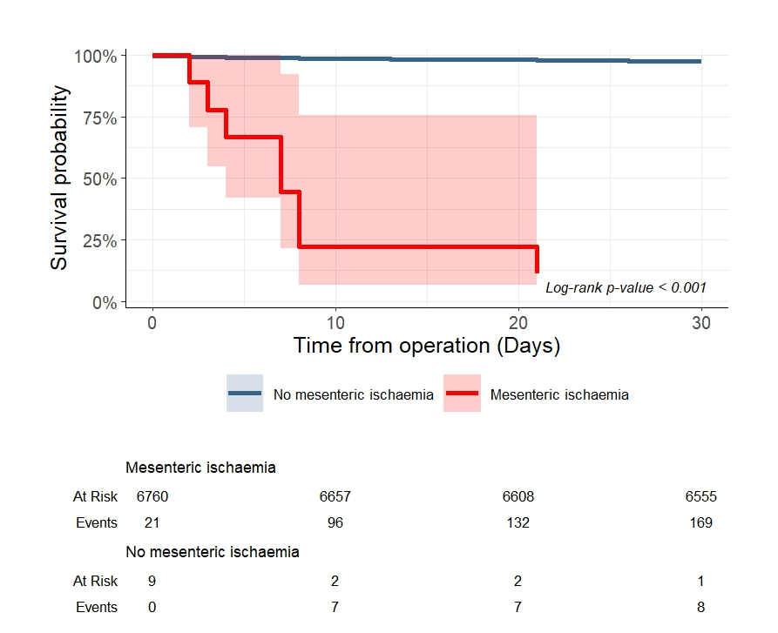

**Supplementary Figure 1: Cumulative survival curve stratified by presence of mesenteric ischaemia.**

**Supplementary Figure 2: Cumulative survival curve stratified by presence of**

**gastrointestinal bleed.** GI: Gastrointestinal.

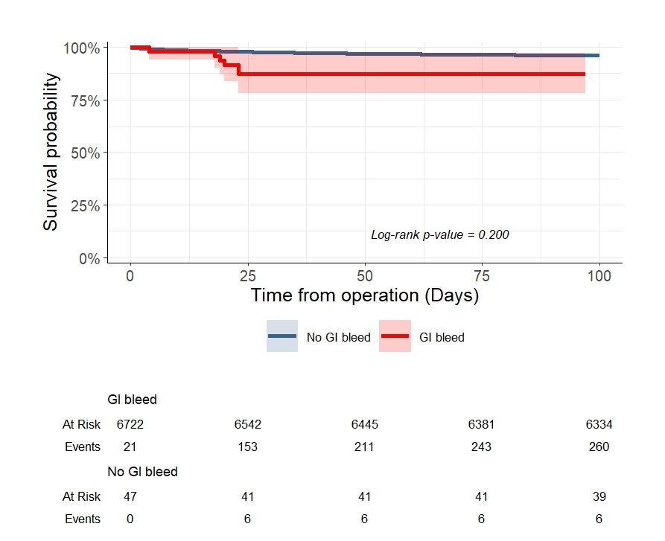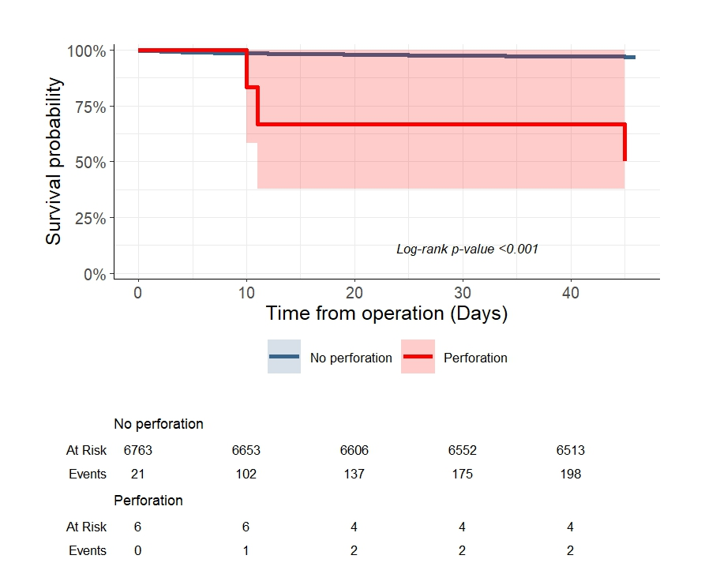

**Supplementary Figure 3: Cumulative survival curve stratified by presence of perforated viscus.**

**Supplementary Figure 4: Number of GI complications per procedure type, with percentage of total in brackets.** AVR: Aortic valve replacement; CABG: Coronary artery bypass grafting; MVR: Mitral valve replacement.

